### List of Inputs, Outputs, and Processing Required

INPUTS

* Title
* Artist
* Release date
* Playback length
* Genre
* Cost to download
* File size (in MegaBytes)
* File path to cover image
* Playlist name
* Name of playlist creator
* Date the playlist was created

OUTPUTS

* The user’s playlist and MP3 files

PROCESSING

* Converting user information a playlist with mp3 files

### Identification of Classes and Their Responsibilities

**Class name:** **MP3**

Responsibilities:

* Getting and setting the information that the user input
* Generating a default file that can be overridden with user information
* Converting the user’s input into a string

**Class name:** **Playlist**

Responsibilities:

* Getting and setting the information that the user input
* Generating a default playlist that can be overridden with user information
* Adding songs to a list of MP3s when the user requests
* Getting the indexed position of the son the user wants to edit
* Getting the indexed position of the son the user wants to delete
* Displaying all songs of a specific Genre or artist
* Sorting all songs by title or release date
* Converting the user’s input into a string

**Class name:** **MP3Driver**

Responsibilities:

* Welcoming the user and storing their name for later
* Giving the user a friendly menu to navigate
* Letting the user create a new MP3 object
* Letting the user create a new playlist object
* Prompting the user for information when needed
* Displaying the user’s MP3
* Displaying the user’s playlist
* Containing all the methods used in the main method that effect the playlist
* Thanking the user when they close the program

### UML Class Diagram

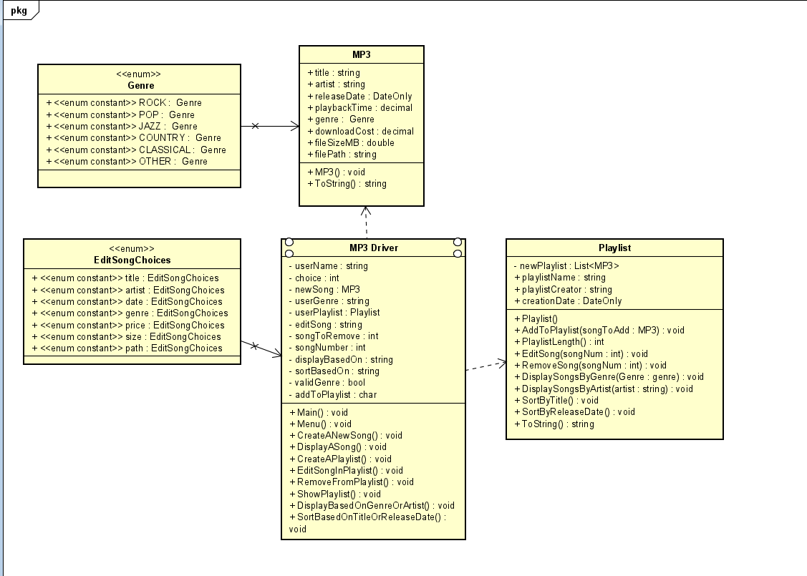

Example Test Case for MP3 class

|  |  |
| --- | --- |
| Inputs | Expected Result |
| Set title to NEXUS  Set artist to Hiroyuki Sawano  Set release date to May 24, 2019  Set playback time to 229 seconds  Set genre to Other  Set download cost to $0.00  Set file size to 4.29 MB  Set file path to C:/Users/Scotty/  Downloads/CoverImage.png  Press 2 with no existing MP3 file | A string displaying all of the input data in the correct order  A prompt telling the user no MP3 exists and that they need to create a new one |

Example Test Case for Playlist class

|  |  |
| --- | --- |
| Inputs | Expected Result |
| Select 4 to try to display a playlist before making one  Select the third option to create a playlist, input the name Funky tunes and the current date  Select 1 and input 7 songs  Song 1:  Title: NEXUS  Artist: Hiroyuki Sawano  Release Date: 5/24/2019  Playback time: 229 seconds  Genre: other  Download Cost: 1.29  File Size: 4.29 MB  filePath: C:/Users/Scotty/  Downloads/CoverImage.png  Song 2:  Title: Clair De Lune  Artist: Claude Debussy  Release Date: 1/1/1905  Playback time: 314 sec  Genre: classical  Download Cost: 0.00  File Size:3.76 MB  filePath: C:/Users/Scotty/  Downloads/CoverImage.png  Song 3:  Title: Dare  Artist: Stan Bush  Release Date: 7/16/1986  Playback time: 241 secs  Genre: Rock  Download Cost: 0.99  File Size: 1.29 MB  filePath: C:/Users/Scotty/  Downloads/CoverImage.png  Song 4:  Title: Cantina Band  Artist: John Williams  Release Date: 5/25/1977  Playback time: 164 seconds  Genre: Jazz  Download Cost: 2.29  File Size: 3.26 MB  filePath: C:/Users/Scotty/  Downloads/CoverImage.png  Song 5:  Title: Somebody That I Used To Know  Artist: Gotye  Release Date: 7/5/2011  Playback time: 243 second  Genre: Pop  Download Cost: 0.99  File Size: 3.46 MB  filePath: C:/Users/Scotty/  Downloads/CoverImage.png  Song 6:  Title: In the Shadow of the Valley  Artist: Don Burnham  Release Date: 7/26/2020  Playback time: 227 second  Genre: Country  Download Cost: 0.00  File Size: 2.64 MB  filePath: C:/Users/Scotty/  Downloads/CoverImage.png  Song 7:  Title: Who’s Ready For Tomorrow  Artist: RATBOY  Release Date: 12/11/2020  Playback time: 116 seconds  Genre: Alternative  Download Cost: 1.29  File Size: 1.97 MB  filePath: C:/Users/Scotty/  Downloads/CoverImage.png | A prompt telling the user no playlist exists and they need to make one  An output saying the playlist was created  Songs 1-6 should output normally since they have valid input  Song 7 will continue prompting the user until a valid genre that is accepted by the program is input |

Creating a new playlist

Adding songs with valid inputs

Trying to add a song with an invalid genre

Displaying every song

Displaying songs based on their genre or artist

Playlist alphabetically sorted by title

Playlist sorted by release date

Both sorting methods refusing invalid information